**School of Computer Science and Artificial Intelligence**

**Lab Assignment # 6.4**

**Program : B. Tech (CSE)**

**Specialization : CSE**

**Course Title : AIAC**

**Course Code : 24CS101PC214**

**Semester : III**

**Academic Session : 2025-2026**

**Name of Student : MAHESH GOUD**

**Enrollment No. : 2403A51407**

**Batch No. : 16**

**Date :10/09/2025**

**TASK 1**

**Prompt:**

**generate a python program to get a class named student with attributes name ,roll number,and marks**

create a condition if he secure more than 45 in marks, give pass otherwise fail and the user should enter the inputs

Screenshot :

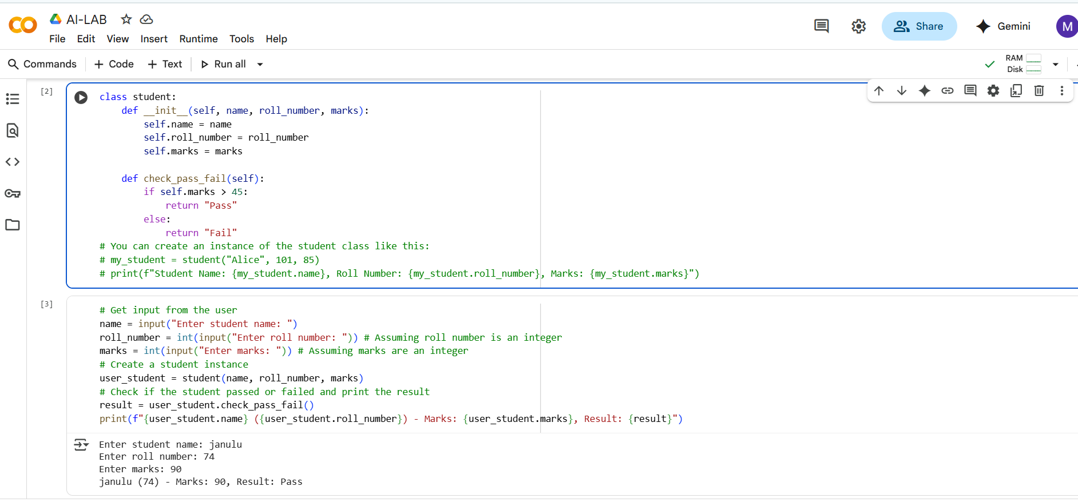

Explaination:

This code defines a student class with attributes for name, roll number, and marks. It also includes a method check_pass_fail which determines if a student passed based on whether their marks are greater than 45. The code then prompts the user to enter the student's name, roll number, and marks, creates a student object with this input, and prints the student's details along with their pass/fail result.

Task 2

Prompt: generate a python code that the first two lines of a for loop that iterates through a list of numbers, which you can then use to calculate and print the square of even numbers.

list of numbers given by the user

Screenshot:

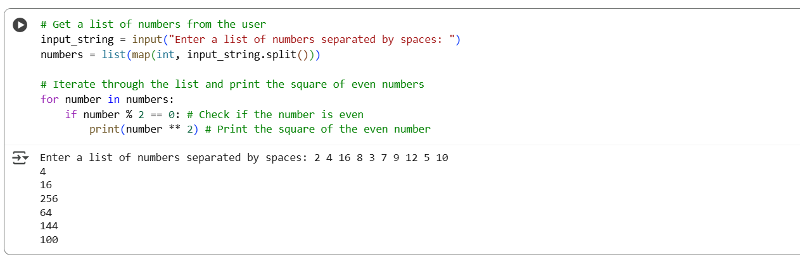

Explaination:

This code prompts you to enter a list of numbers separated by spaces. It then converts the input string into a list of integers. Finally, it iterates through this list, checks if each number is even, and if it is, it prints the square of that number.

Task 3

Prompt: generate the python code that creates the class named bank account with attributes account holder and balance and also use the methods for deposit(), withdraw(), and check for insufficient balance and give output by uncommenting the example

Screenshot:

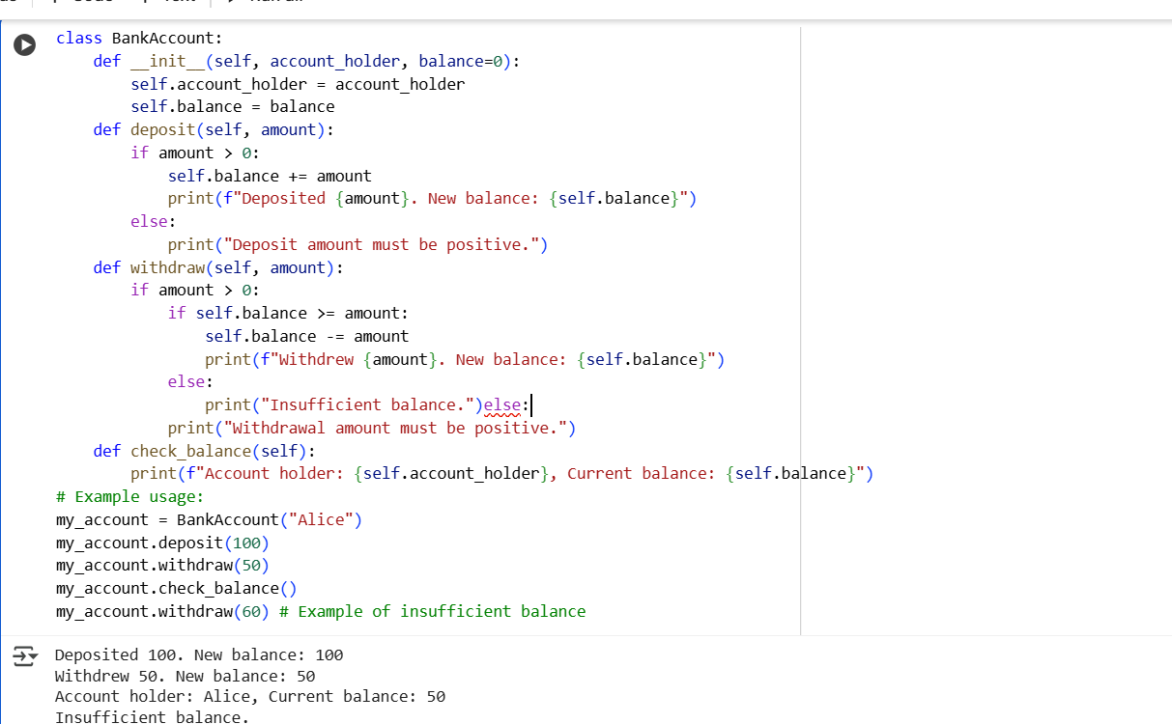

Explaination:

This code defines a BankAccount class to simulate bank accounts. It has methods to deposit money, withdraw money (checking for insufficient balance), and check_balance to display the current balance and account holder. The example usage at the end demonstrates how to create an account, deposit, withdraw, and check the balance.

Task 4

Prompt:

generate a python program to define a list of student dictionaries with keys name and score along that use the while loop to print the names of students who scored more than 75

Screenshot:

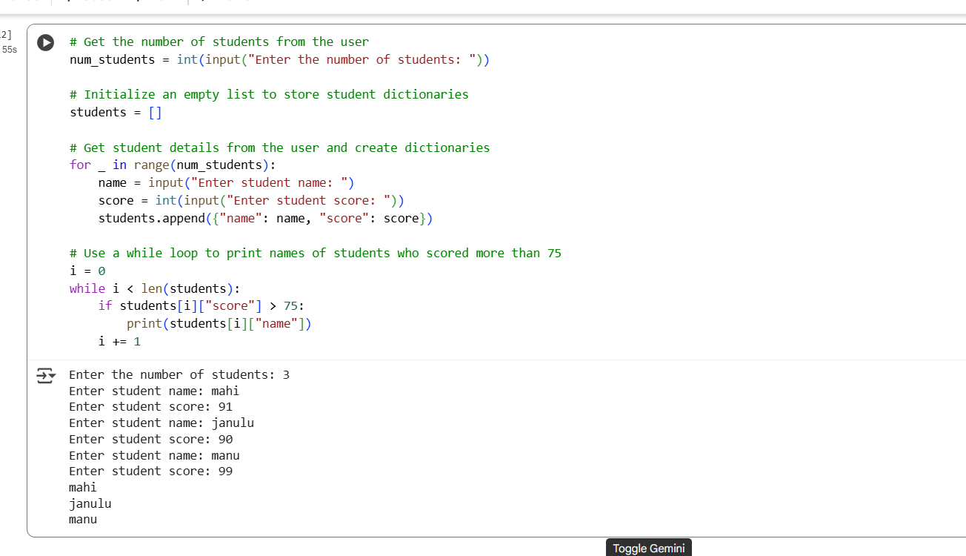

Explaination:

This code defines a list called students, where each item is a dictionary containing a student's name and score. It then uses a while loop to go through each student in the list. Inside the loop, it checks if the student's score is greater than 75, and if it is, it prints the student's name.

Task 5

Prompt :

write a python program to create a class named shoppingcart containing empty list items and generate methods to add_item, remove_item, and use a loop to calculate the total bill using conditional discounts. with using if else statements and loops

Screenshots:

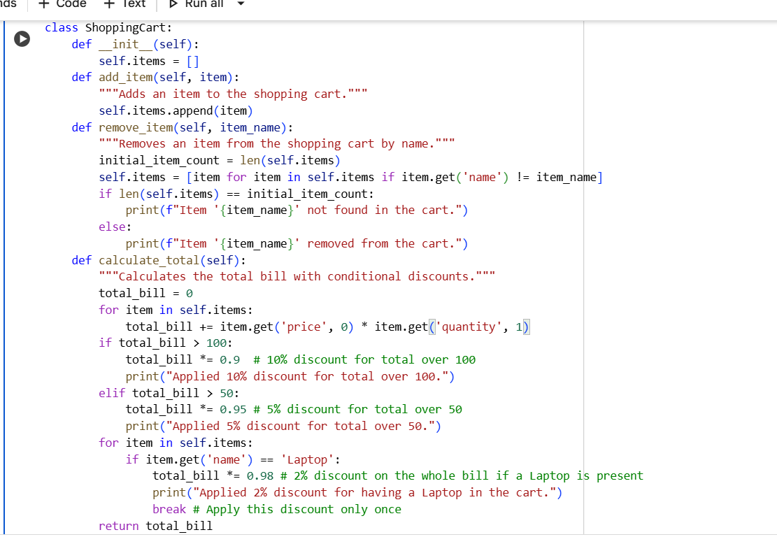

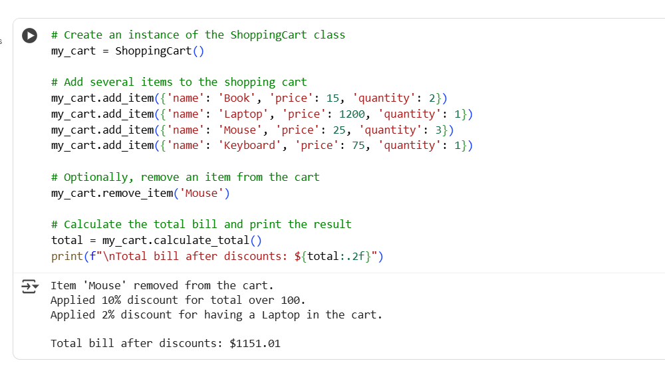

Explaination:

This code defines a Python class named ShoppingCart. The __init__ method is the constructor of the class. When you create a new ShoppingCart object, this method is automatically called, and it initializes an empty list called self.items. This list will be used to store the items added to the shopping cart.